HORARIOS HORAS

4:**00 FOUR CLOCK**

**4:10 Four ten**

**4:15 Four fifteen / It's a quarter past Four**

**4:20 four twenty**

**4:25 four twenty-five**

**4:30 It's four thirty**

**4:35 It's four thirty-five**

**4:40 It's four forty**

**4:45 It's four forty-five/ It' a quarter to five**

**4:50 It's four fifty**

**4:55 It's five to five /It's four fifty-five**

**5:00** **It's five o'clock**

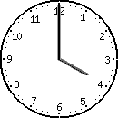 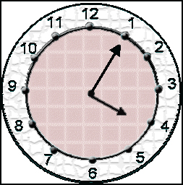 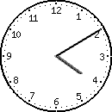

4:**00 FOUR CLOCK 4:05 FOUR O FIVE 4:00 Four Ten**

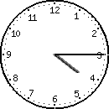 

**4:15 Four fifteen / It's a quarte past Four 4:20 four twenty**

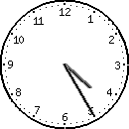 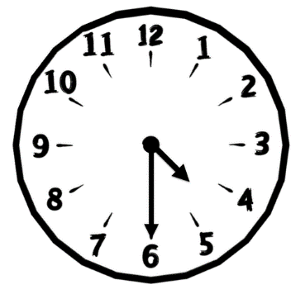 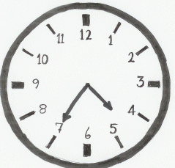

**4:25 four twenty-five 4:30 It's four thirty 4:35 It's four thirty-five**

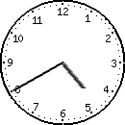 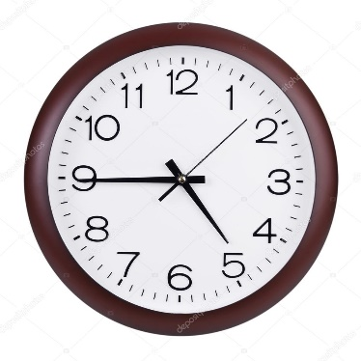 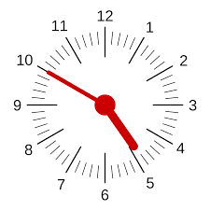

**4:40 It's four forty 4:45 It's four forty-five/ It' a quarter to five 4:50 It's four fifty**

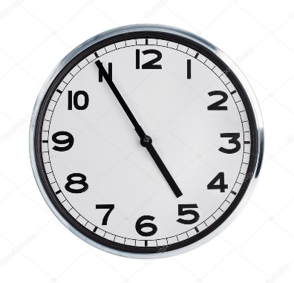 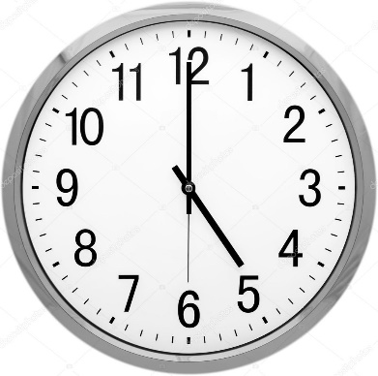

**4:55 It's five to five /It's four fifty-five 5:00** **It's five o'clock**